**Abstract:**

A **Zener diode** is a [diode](http://en.wikipedia.org/wiki/Diode) which allows current to flow in the forward direction in the same manner as an ideal diode, but also permits it to flow in the reverse direction when the voltage is above a certain value known as the [“breakdown voltage”](http://en.wikipedia.org/wiki/Breakdown_voltage), "zener knee voltage", "zener voltage", "avalanche point", or "peak inverse voltage".

**Introduction:**

The main objective of this experiment is to-

**1.** Study the voltage-current characteristics of Zener diode and **2.** Observe the voltage regulation characteristics of a Zener Diode.

**Theory and Methodology:**

The basic function of **Zener diode** is to maintain a specific voltage across its terminals within given limits of line or load change. Typically it is used for providing a stable reference voltage for use in power supplies and other equipment.

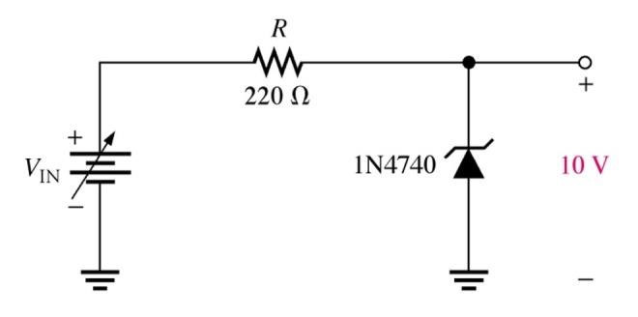

Figure 1: This particular Zener circuit will work to maintain 10 V across the load.

A **Zener diode** is much like a normal diode, the exception being is that it is placed in the circuit in reverse bias and operates in reverse breakdown. This typical characteristic curve illustrates the operating range for a Zener. Note that its forward characteristics are just like a normal diode.

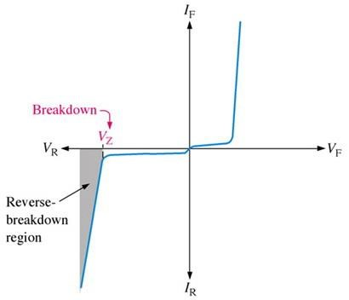

Figure 2: The normal operating region for a Zener diode is shaded

The doping process determines the Zener diode’s breakdown characteristics. Low voltage Zeners less than 5V operate in the Zener breakdown range. Those designed to operate more than 5 V operate mostly in avalanche breakdown range. Zeners are available with voltage breakdowns of 1.8 V to 200 V.

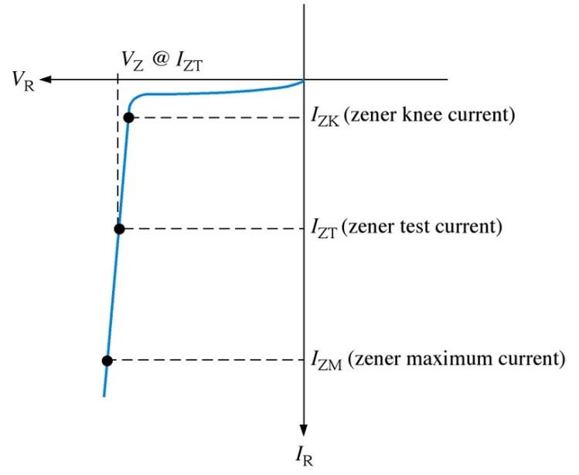

Figure 3: This curve illustrates the minimum and maximum ranges of current operation that the Zener can effectively maintain its voltage.

A voltage regulator is designed to keep the output voltage of a circuit at a constant value, independent of the input voltage and also independent of the load current. A Zener diode connected in parallel to the load is the simplest form of such a voltage regulator circuit shown in figure 1(right) in the Circuit Diagram part. If the voltage across the load tries to rise, then the Zener diode takes more current. The increase in current through the resistor causes an increase in voltage dropped across the resistor and the causes the voltage across the load to remain at its correct value. Similarly, if the voltage across the load tries to fall, then the Zener diode takes less current. The current through the resistor and the voltage across the resistor both fall down. The voltage across the load remains at its correct value.

**Apparatus:**

1) ZenerDiode : [1 pc]

2) Trainer Board :

* 1. Resistors : 100Ω [ 1 pc ]

220Ω [ 1 pc ]

470Ω [ 1 pc ]

* 1. Oscilloscope

* 1. Multimeter : [ 1pc ]
  2. Chord : [ 2pcs]
  3. POT 100kΩ [ 1pc ]
  4. DC Power Supply

**Circuit Diagram:**

V

V

D

V

R1

R

1

= 470

Ω

V

V

L

470

Ω

V

R

1

0

K

P

O

T

1

0

0

Ω

Figure 4: Zener Diode Circuits

**Experimental Procedure:**

**Table – 1: Data Table for V – I characteristics using experimental values**

|  |  |  |  |
| --- | --- | --- | --- |
| **V (volt)** | **VR1 (volt)** | **VZ (volt)** | **I = (VR1/R1) (A)** |
|  |  |  |  |
|  |  |  |  |
|  |  |  |  |
|  |  |  |  |
|  |  |  |  |
|  |  |  |  |
|  |  |  |  |
|  |  |  |  |
|  |  |  |  |
|  |  |  |  |

**Table – 2: Data Table for Regulation due to load variation using experimental values**

|  |  |  |  |  |
| --- | --- | --- | --- | --- |
| **VR (mV)** | **100** | **300** | **500** | **700** |
| **VL (volts)** |  |  |  |  |
| **IL= (VR/R) (A)** |  |  |  |  |

**Table – 3: Table for regulation due to supply voltage variation using experimental values**

|  |  |  |  |  |
| --- | --- | --- | --- | --- |
| **V (volts)** | **16** | **12** | **9** | **6** |
| **VR (volts)** |  |  |  |  |
| **VL (volts)** |  |  |  |  |

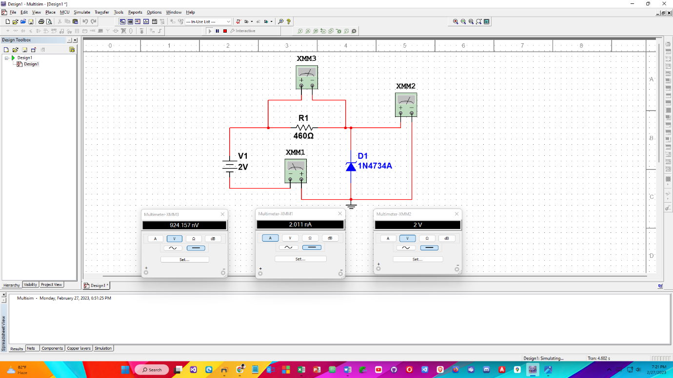**Simulation**

